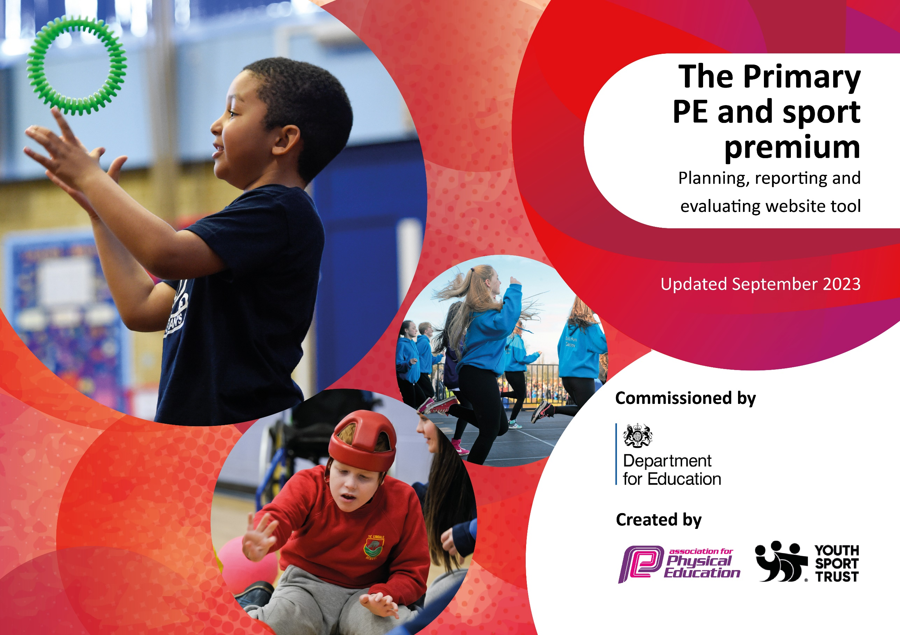

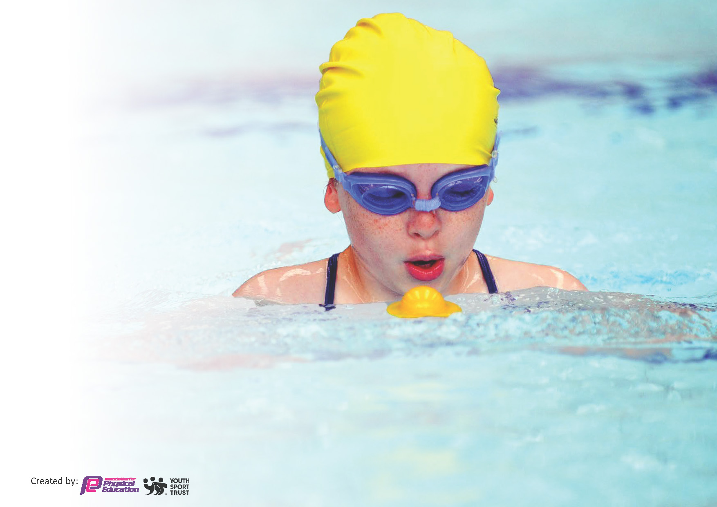
This template can be used for multiple purposes:
by:
- It enables schools to effectively plan their use of the Primary PE and sport premium
- It helps schools to meet the requirements (as set out in guidance) to publish information on their Primary PE and sport premium
- It will be an effective document to support Ofsted inspections enabling schools to evidence progress in Physical Education (PE) and evidence swimming attainment, which forms part of the PE National Curriculum. We would recommend schools consider
the Intent, Implementation and Impact of any spend, as examined within the Education Inspection Framework.

It is important that your grant is used effectively and based on school need.

Schools must use the funding to make additional and sustainable
improvements to the quality of the PE, School Sport and Physical Activity (PESSPA)
they offer. This means that you should use the Primary PE and sport premium to:

- Build capacity and capability within the school to ensure that improvements made now will benefit pupils joining the school in future years
- Develop or add to the PESSPA activities that your school already offers.

The Primary PE and sport premium should not be used to fund capital spend projects; the school’s core budget should fund these. Further detail on capital expenditure can be found in the updated Primary PE and sport premium guidance.

The Primary PE and sport premium guidance, outlines 5 key priorities that funding should be used towards. It is not

necessary that spending has to meet all the key priorities, you should select the priorities that you aim to use any funding towards.

Although completing this template is not a requirement for schools, schools are required to publish details of how they spend this funding. Schools must also outline what the impact this funding has had on pupils’ PE and sport participation and attainment and how any spending will be sustainable in the future. All funding must be spent by 31st July 2024.

The Department for Education has worked closely with the Association for Physical Education (afPE) and the Youth Sport Trust (YST) to develop this template and encourages schools to use it. This template is an effective way of meeting the reporting requirements of the Primary PE and sport premium.
Review of last year’s spend and key achievements (2022/2023)

We recommend you start by reflecting on the impact of current provision and reviewing your previous spend.

Activity/Action | Impact | Comments
All the children in the current Y5 class to receive Sports Leader training. A timetabled rota will be provided for them so that they knew when and where they would be undertaking their roles. They will be provided with an activity pack that gives lots of examples of simple/easy playground activities that they can set up and offer to the other children in school whilst undertaking their role.  Play Leader Equipment bag purchased to support delivery of playground leader activities.  Through our subscription to PE Passport, children are offered 2 hours of high-quality PE each week in which they participate in active lessons that offer them opportunities to practise and extend their skills in a variety of areas, enabling them to become more confident and competent movers and develop a lifelong enjoyment of moving and being active.  A long-term curriculum based on the PE Passport and offers a broad and balanced approach to all areas of the PE national curriculum. The IPAD based tool enables staff to access detailed planning and easy assessment tools.  Promote healthy ways to travel to school eg walking, scooters or bikes.  - Enrolment into South Ribble Sports Active travel programme. Through this the following was provided  - SCOOT SAFE  - Tots on Tyres Combined L1 and 2 (EYFS and Y1)  - DR Bike (Y5)  - Bike Fix (Whole School)  - Active Travel Assembly  - BIKEABILITY (Free)  Maintain and replenish stock to ensure that high quality PE sessions and games can be undertaken. Equipment purchased to replenish stock and support delivery of playground leader activities.  Opal intervention equipment. Equipment to support the successful delivery of Opal intervention at break and lunch times  Lunch time Sports Club= Sports Cool  Coaches come in two afternoons a week to run optional sports clubs at lunch times to encourage active playtimes  Summer 1 & Summer 2  Total – £8840.40 | Training for playleaders provides the children with more varied opportunities to participate in activities over lunch which have had a positive impact on behaviour management.  A variety of equipment that is in good repair allows children to engage productively and positively in playground activities set up by lunchtime staff and playleaders.  Staff have continued the implementation of the PE Passport scheme of work. They have delivered many of the termly units whilst also working some sessions delivered by PNE coaches.  Through these programmes’ children from Y3 onwards are able to come into school on their scooter. From Y5 onwards, after they have reached a level of proficiency and passed their course the pupils can come into school on their bike. We currently have between 10-15 children using their bikes as transport. From EYFS and in KS1 the children are taught age appropriate bike skills to prepare them for riding a bike.  School now as a fully replenished PE cupboard that is easily accessible to all staff and children. Equipment is clearly placed and labelled and we now have the correct equipment to deliver our lessons and extracurricular clubs to the highest standard.  Children have been a lot more engaged during play times. With more options for the children to do children have been more active and behaviour has improved as children are busy | Year 5 are developing their leaderships skills and problem solving amongst peers. Lunchtime staff and play leaders will continue to offer and support active lunchtimes in the new academic year.  The school will continue to use the PE Passport scheme of work next year. Staff are more confident with this and the use of it towards assessment. Although content is currently being delivered by the class teacher and some units by specialist coaches from PNE, next year staff are confident enough to deliver without the coaches.  The training provided by the Active Schools programmes not only gives them bike handling skills now but provides them with skills for life. Encourage children and families to use ‘healthy forms of ‘transport’ to come to school eg: bike, walk or scooter. Monitor this each term  We will place an order for the start of the new academic year to replenish our stock again.  We will carry this on next year as it has been successful.
Develop teachers’ skills and knowledge in activities that will engage and inspire our pupils to take part in life long activities. 4 weekly pe sessions delivered by outside coach from PNE. Staff work alongside the coach to support, teach and upskill themselves. Children participate actively in sessions.  Use lessons that are active to increase physical activity levels whilst learning.  Promote outside agencies that offer opportunities for children to participate in afterschool/ weekend or holiday clubs  Sign post children who show talent to local clubs such as Preston Harriers, Penwortham Cricket Club and local football clubs  Ensure that sport and PE is visible across school  Use PE and sport to develop the whole person including thinking, social, emotional and skills and teamwork.  New PE uniform for Staff  New Netball Kit, new football nets and netting for netball hoops. Children and staff representing the school wearing clothing appropriate for that sport and delivering PE sessions/ extra-curricular activities  New nets needed to support extracurricular clubs  Total - £1130 | Staff skills, subject knowledge and confidence improve whilst working alongside the coach. PE and sport outside school is supported by school. Regular ‘flyers’ and announcements are sent home to children via paper copies and attached electronically to the school newsletter.  Staff encourage families to seek further extension of skills for the children who show interest or promise at local clubs and providers. Staff support the philosophy of developing the ‘whole child’ through sport and PE  Pupils were excited to watch professionals and this created a positive feel in school when they  came back.
Raise the quality of teaching and learning in PE and school sport by providing support to deliver a broad and balanced, inclusive, high quality lessons. Staff work alongside coaches to deliver high quality sessions and for their CPD  Encourage coaches employed to deliver the PE curriculum alongside the staff and increase their confidence in the delivery of sessions. Use of specialist coaches from PNE/ to increase the knowledge and confidence of teachers delivering PE  Pupil questionnaires to monitor their attitudes towards PE and Sport in school. KS1 and KS2 attitude and participation questionnaires to be undertaken in Spring 2022  6 Days of Subject Leader time allocated to BS- 1 Per term to ensure  Total - £4950 | Increased staff knowledge and understanding. All teachers more confident in teaching and assessing of PE More confident and competent staff evidenced through staff and pupil feedback Enhanced quality of provision A more inclusive curriculum that inspires and engages all pupils Continued progression of all pupils  during PE curriculum lessons Questionnaires and pupil  feedback/discussions inform us that pupils enjoy the activities that we offer in school. | We will not be continuing with PNE next year as staff feel as though they have gained sufficient CPD from them other the last few years.  We will be sending out staff questionnaires to ask if any staff would like more directed and specific CPD in PE and therefore fund that with next year’s Sports premium funding.
Identify which activities pupils would like to try by year group. Ensure that school are providing activities that will engage the most pupils as well as the least active. Pupil questionnaires to be carried out to identify lunchtime activities that the children in different Key stage s would like. From this information, lunchtime activities are provided for different groups of classes according to their preferences: YR1/2, Y3/4 and Y5/6  Develop opportunities to access clubs provided by sports coaches at lunchtimes. Boys and girls football clubs  Netball for boys and girls in Y5/6  Competitive league fixtures in Netball  Football, Dodgeball, Tennis, Cricket, Dance, Multi-skills, Bowling, Rugby.  Provide opportunities to take part in a range of sports through extra-curricular clubs, competitions and events.  All key stage 2 children participate in at least a day of Outdoor and Adventurous activity (Y6 3 day residential. Y3/4 pupils to attend the Anderton Centre and take part in land-based activities.  Y5 also attended but participated in water-based activities.  Y6 on a 3-day residential trip to Robin Wood  Total - £1700 | Lunchtime clubs were very well attended by all classes a and provided an extra dimension to the provision available to engage the children at this time Over 20 pupils both boys and girls attended the football training sessions and the Netball Club. Not all the pupils were the same for both clubs, although some did attend both.  All children engaged fully with their activities and very positive feedback was received from parents and the children. The children were able to experience of OAA type activities that provided them with differing experiences from the types of activities that they can access at school. | Not continuing with PNE next academic year but we are using another company to provide extra after school and lunch time clubs.  Bookings will be made for next Summer 23 so that the children have an opportunity to experience a different type of activity. Look to using sports funding to assist families on lower incomes or PP children.

Key priorities and Planning - £17,690
This planning template will allow schools to accurately plan their spending.

Action – what are you planning to do | Who does this action impact? | Key indicator to meet | Impacts and how sustainability will be achieved? | Cost linked to the action
South Ribble School Sports Partnership | Staff and Pupils | Key indicator 1: Increased confidence, knowledge and skills all staff in teaching PE.  Key indicator 2: Engagement of all pupils in regular physical activity  Key indicator 3: The profile of PE and sport is raised across school as a tool for whole school improvement.  Key indicator 4: Broader experience of a range of sports and activities offered to all pupils.  Key indicator 5: Increased participation in competitive sport. | Staff are upskilled by trained specialist coaches. Many aspects of the program are required to be delivered by qualified staff who can award completion certificates to pupils of the school. Extra-curricular clubs increase sporting opportunities and engagement while competitions lead by SRBC are well organised and well attended by Middleforth pupils. | £5040
Swimming for the whole school, including nursery | Pupils | Key indicator 1: Increased confidence, knowledge and skills all staff in teaching PE.  Key indicator 2: Engagement of all pupils in regular physical activity  Key indicator 3: The profile of PE and sport is raised across school as a tool for whole school improvement.  Key indicator 4: Broader experience of a range of sports and activities offered to all pupils. | All teachers to observe the teaching of swimming to upskill them in the delivery of swimming.  All pupils engaging in more physical activity each day.  Children’s excitement and enthusiasm for swimming increases and therefore they are safer around water (water safety).  All pupils offered the opportunity to swim in a safe environment. | £8750
Increased Physical Activity for all pupils each day | Pupils | Key indicator 2: Engagement of all pupils in regular physical activity  Key indicator 3: The profile of PE and sport is raised across school as a tool for whole school improvement.  Key indicator 4: Broader experience of a range of sports and activities offered to all pupils. | Portable equipment to support physical development for all pupils form EYFS to Year 6 at break and lunch times. | £2900
CPD for all staff | Pupils and Staff | Key indicator 1: Increased confidence, knowledge and skills all staff in teaching PE. | Staff to be upskilled in delivering a range of sports with more confidence | £1000

Key achievements 2023-2024
This template will be completed at the end of the academic year and will showcase the key achievements schools have made with their Primary PE and sport premium spending.

Activity/Action | Impact | Comments
To be completed at the end of the year.

Swimming Data
Meeting National Curriculum requirements for swimming and water safety.
Priority should always be given to ensuring that pupils can perform safe self-rescue even if they do not fully meet the first two requirements of the National Curriculum programme of study

Question | Stats: | Further context  Relative to local challenges
What percentage of your current Year 6 cohort can swim competently, confidently and proficiently over a distance of at least 25 metres? | % | Use this text box to give further context behind the percentage.  e.g., 30% - we are struggling to get pool space due to our local pool closing so we have had to use a much smaller local school pool. We have had to limit the number of pupils attending swimming lessons during one term which means some pupils have attended fewer swimming lessons than others.
What percentage of your current Year 6 cohort can use a range of strokes effectively [for example, front crawl, backstroke, and breaststroke]? | % | Use this text box to give further context behind the percentage.  e.g., Even though your pupils may swim in another year please report on their attainment on leaving primary school at the end of the summer term 2024

What percentage of your current Year 6 cohort are able to perform safe self-rescue in different water-based situations? | % | Use this text box to give further context behind the percentage.
If your schools swimming data is below national expectation, you can choose to use the Primary PE and sport premium to provide additional top-up sessions for those pupils that did not meet National Curriculum  requirements after the completion of core lessons. Have you done this? | Yes/No
Have you provided CPD to improve the knowledge and confidence of staff to be able to teach swimming and water safety? | Yes/No

Signed off by:

Head Teacher: | (Name)
Subject Leader or the individual responsible for the Primary PE and sport premium: | (Name and Job Title)
Governor: | (Name and Role)
Date:

