 | Autumn 1 |  | Autumn 2 | Spring 1 |  | Spring 2 |  | Summer 1 |  | Summer 2
Nursery/Rec | Access to Mini-mash and Purplemash in continuous provision throughout the year.
Key to specific area of Computing | 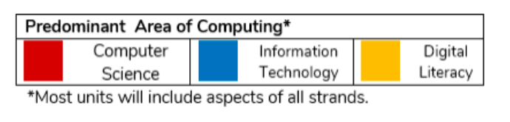
Year 1 | Exploring PurpleMash | Grouping and Sorting | Online Safety | Lego Builder  Maze Explorers |  | Digital Literacy - Animated Story Books |  | Coding (code.org) |  | Spreadsheets
 |  |  |  |  |  |  |  |  |  | Using Technology Outside of school
Year 2 | Online Safety  (Project Evolve) |  | Coding (code.org) | Questioning |  | Creating Pictures |  | Making Music | Effective Searching | Presenting Ideas
Year 3 | Online Safety  (Project Evolve) |  | Coding (code.org) | Touch Typing and Spreadsheets |  | Email (Including Email safety) |  | Simulations | Graphing | Presenting Ideas
Year 4 | Online Safety  (Project Evolve) |  | Coding (code.org) | Spreadsheets |  | Writing for different Audiences |  | Effective Searching | Animation | Making Music | Hardware Investigators
Year 5 | Online Safety  (Project Evolve) |  | Coding (code.org) | Spreadsheets |  | Game Creator |  | 3D Modelling | Concept Maps | Word processing
Year 6 | Online Safety  (Project Evolve) |  | Coding (code.org) | Blogging | Networks | Text Adventures | Binary | Quizzing |  | Spreadsheets | Excel

Online safety – Project Evolve - https://projectevolve.co.uk/toolkit/resources/
6 lessons to begin with and lessons implemented throughout the year if required -

Coding – Code.org - https://code.org/
Coding
Nursery/Rec | Digital literacy – Jigsaw
Year 1 | Computer Science Fundamentals – Course A  Extension: Artist
Year 2 | Computer Science Fundamentals – Course B  Extension: Code with Anna and Elsa
Year 3 | Computer Science Fundamentals – Course C & Course D  Extension: Choose your team and make a basketball game, Code your own sports game
Year 4 | Computer Science Fundamentals – Course E  Extension: Flappy Code, Classic Maze (Angry Birds)
Year 5 | Computer Science Fundamentals – Course F  Extension: Minecraft designer, Minecraft hero’s journey, Minecraft Voyage Aquatic.
Year 6 | Computer Science Fundamentals – Express course  Extension: Dance Party (2018), Keep on Dancing (2019)

Purple Mash – every other aspect of the curriculum.
All pupils to have logins and can access Purple Mash for homework, if required.

