 | Autumn 1 | Autumn 2 | Spring 1 | Spring 2 | Summer 1 | Summer 2
Nursery
Reception |  | Drawing: Marvellous marks |  | Painting and Mixed Media: Paint my world |  | Sculpture and 3D: creation station
Year 1 |  | Drawing: Making your mark |  | Painting and Mixed Media: Colour Splash |  | Sculpture and 3D: Paper Play
Year 2 | Drawing: Telling a story |  | Sculpture 3D: Clay houses |  | Craft ad Design: Map it out
Year 3 |  | Painting and Mixed media: Prehistoric media |  | Drawing: Growing artists |  | Craft and Design: Ancient Egyptian scrolls
Year 4 |  |  | Painting and mixed media: Light and dark |  | Craft and design: Florals of nature | Drawing: Power Prints
Year 5 |  | Craft and Design: Architecture |  | Painting and mixed media: Portraits |  | Sculpture and 3D: Interactive installation
Year 6 | Craft and Design: Photography |  | Painting and Mixed Media: Artist study |  | Still life

Nur | National Curriculum | Progression steps | Vocabulary
Three- and Four-Year olds:
Physical Development
- Use large-muscle movements to wave flags and streamers, paint and make marks.
- Choose the right resources to carry out their own plan.
- Use one-handed tools and equipment, for example, making snips in paper with scissors.
- Use a comfortable grip with good control when holding pens and pencils.
Expressive Arts and Design
- Explore different materials freely, in order to develop their ideas about how to use them and what to make.
- Develop their own ideas and then decide which materials to use to express them.
- Join different materials and explore different textures.
- Create closed shapes with continuous lines, and begin to use these shapes to represent objects.
- Draw with increasing complexity and detail, such as representing a face with a circle and including details.
- Use drawing to represent ideas like movement or loud noises.
- Show different emotions in their drawings and paintings, like happiness, sadness, fear, etc.
- Explore colour and colour mixing.
Autumn Term
Unit:
Unit
Spring Term
Unit:
Unit
Summer Term
Unit:
Unit

Reception | National Curriculum | Progression steps | Vocabulary
Physical Development
- Develop their small motor skills so that they can use a range of tools competently, safely and confidently.
- Use their core muscle strength to achieve a good posture when sitting at a table or sitting on the floor.
- Develop overall body-strength, balance, coordination and agility.
Expressive Arts and Design
- Explore, use and refine a variety of artistic effects to express their ideas and feelings.
- Return to and build on their previous learning, refining ideas and developing their ability to represent them.
- Create collaboratively, sharing ideas, resources and skills.

ELG- Physical Development- Fine Motor Skills
- Hold a pencil effectively in preparation for fluent writing - using the tripod grip in almost all cases.
- Use a range of small tools, including scissors, paintbrushes and cutlery.
- Begin to show accuracy and care when drawing.
Expressive Arts and Design-Creating with Materials
- Safely use and explore a variety of materials, tools and techniques, experimenting with colour, design, texture, form and function.
- Share their creations, explaining the process they have used.
Autumn Term
Unit: Drawing: Marvellous Marks | Physical development  Develop small motor skills so that they can use a range of tools competently, safely and confidently.  ELG: Fine Motor Skills: Begin to show accuracy and care when drawing.  Expressive arts and design  Explore, use and refine a variety of artistic effects to express ideas and feelings.  ELG: Creating with materials: Safely use and explore a variety of materials, tools and techniques, experimenting with colour, design, texture, form and function.  Characteristics of effective learning  Playing and exploring. | Exploring mark making through different drawing materials. Beginning to draw from observation using faces and self-portraits as a stimulus.  - To investigate the marks and patterns made by different textures.  - To explore making marks with felt tips.  - To compare different ways of making marks and drawing (chalk).  - To explore mark making using pencils.  - To create a simple observational drawing.  - To use a variety of colours and materials to create a self-portrait. | Colours  Pencils  Chalk  Felt tips  Drawing  Observe  Material  Portrait  Pattern  Texture  Mark-making
Spring Term
Unit: Painting and mixed media: Paint my world | Physical development  Develop small motor skills so that they can use a range of tools competently, safely and confidently.  ELG: Fine Motor Skills: Begin to show accuracy and care when drawing.  Expressive arts and design  Explore, use and refine a variety of artistic effects to express ideas and feelings.  ELG: Creating with materials: Safely use and explore a variety of materials, tools and techniques, experimenting with colour, design, texture, form and function.  Characteristics of effective learning  Playing and exploring. | Exploring paint and painting techniques through nature, music and collaborative work. Developing creativity through child-led exploration of mixed-media, making collages and transient art.  - To explore paint through finger painting.  - To create natural paintbrushes using found objects.  - To use paint to express ideas and feelings.  - To make child-led collages using mixed media.  - To create landscape collages inspired by the work of Megan Coyle.  - To create a large piece of group artwork based around fireworks. | paint  natural objects  collage  design  landscape  collage  Megan Coyle  firework
Unit: Sculpture and 3D: Creation station | Physical development  Develop small motor skills so that they can use a range of tools competently, safely and confidently.  ELG: Fine Motor Skills: Begin to show accuracy and care when drawing.  Expressive arts and design  Explore, use and refine a variety of artistic effects to express ideas and feelings.  ELG: Creating with materials: Safely use and explore a variety of materials, tools and techniques, experimenting with colour, design, texture, form and function.  Characteristics of effective learning  Playing and exploring. | Exploring the sculptural qualities of malleable materials and natural objects; developing the use of tools and joining techniques; designing and making clay animal sculptures.  - To explore clay and its properties.  - To explore playdough and its properties.  - To create natural 3D landscape pictures using found objects.  - To generate conversation and inspiration about sculpture artists and their art.  - To begin making a 3D clay sculpture.  - To share their creation, explaining the processes they have used. | Clay  Properties  3D- Dimension  Natural  Sculpture  Artist  Creation  Process
Summer Term
Unit: Craft and design: Let's get crafty | Physical development  Develop small motor skills so that they can use a range of tools competently, safely and confidently.  ELG: Fine Motor Skills: Begin to show accuracy and care when drawing.  Expressive arts and design  Explore, use and refine a variety of artistic effects to express ideas and feelings.  ELG: Creating with materials: Safely use and explore a variety of materials, tools and techniques, experimenting with colour, design, texture, form and function.  Characteristics of effective learning  Playing and exploring. | Developing cutting, threading, joining and folding skills through fun, creative craft projects.  - To develop scissor skills.  - To develop threading skills.  - To learn about the different ways in which we can join materials together and to practise these techniques.  - To learn how to fold, curl and cut paper to achieve a desired effect.  - To create a design for a tissue paper flower.  - To refine small motor skills through the use of drawing, cutting and manipulating paper. | Scissors  Threading  Cutting  Sticking  Materials  Joining  Attach  Folding  Curling  Tissue paper
Additional units | Seasonal: A craft for each season, including Easter and Christmas.  Autumn craft: Nature wreaths: Designing and making autumn wreaths using natural objects; exploring colour and pattern to create individual designs.  Winter craft: Threaded snowflakes: Making pipe-cleaner snowflakes; applying skills with threading; choosing colours and shapes to create patterns.  Christmas craft: Salt dough decorations: Manipulating salt dough and using a range of tools to create a Christmas decoration.  Spring craft: Petal mandala suncatchers: Learning about the patterns, colours and symbolism of mandalas to create a suncatcher version using collected leaves and petals.  Easter craft: Egg threading: Applying skills in threading wool; making choices about patterns and colours; creating hanging Easter decorations.  Summer craft: Salt painting: Painting imaginative designs with salt; experimenting with colour and texture; describing the processes they have used.

Year 1 | National Curriculum | Progression steps | Vocabulary
Autumn Term
Unit: Drawing- Making your mark | - To develop a wide range of art and design techniques in using colour, pattern, texture, line, shape, form and space  - To use drawing, painting and sculpture to develop and share their ideas, experiences and imagination  - Use a range of materials creatively to design and make products  - To know about the work of a range of artists, craft makers and designers, describing the differences and similarities between different practices and disciplines, and making links to their own work | Developing observational drawing skills when exploring mark-making. Children use a range of tools, investigating how texture can be created in drawings. They apply their skills to a collaborative piece using music as a stimulus and investigate artists Bridget Riley and Zaria Forman.  - To know how to create different types of lines.  - To explore line and mark-making to draw water.  - To draw with different media.  - To develop an understanding of mark making.  - To apply an understanding of drawing materials and mark-making to draw from observation. | 2D shape  3D shape  abstract  chalk  charcoal  circle  continuous  cross-hatch  diagonal  dots  firmly  form  horizontal  lightly | line  mark making  narrative  observe  optical art  pastel  printing  shade  shadow  straight  texture  vertical  wavy
Spring Term
Unit: Painting and Mixed Media: Colour Splash | - To develop a wide range of art and design techniques in using colour, pattern, texture, line, shape, form and space  - To learn about the work of a range of artists, craft makers and designers, describing the differences and similarities between different practices and disciplines, and making links to their own work  - To develop a wide range of art and design techniques in using colour, pattern, texture, line, shape, form and space, to use drawing to develop and share their ideas, experiences and imagination  - Evaluate and analyse creative works using the language of art, craft and design | Exploring colour mixing through paint play, children use a range of tools and work on different surfaces. They create paintings inspired by Clarice Cliff and Jasper Johns.  - To investigate how to mix secondary colours.  - To apply knowledge of colour mixing when painting.  - To explore colour when printing.  - To experiment with paint mixing to make a range of secondary colours.  - To apply their painting skills when working in the style of an artist. | blend  hue  kaleidoscope  pattern  mix  primary colour  print  secondary colour  shade  shape  space  texture  thick
Summer Term
Unit: Sculpture and 3D: Paper Play | - Use a range of materials creatively to design and make products  - Use drawing, painting and sculpture to develop and share their ideas, experiences and imagination  - Learn about the work of a range of artists describing the differences and similarities between different practices and disciplines, and making links to their own work  - Develop a wide range of art and design techniques in using colour, pattern, texture, line, shape, form and space  - Become proficient in drawing, painting, sculpture and other art, craft and design techniques | Creating simple three dimensional shapes and structures using familiar  materials, children develop skills in manipulating paper and card. They fold, roll and scrunch materials to make their own sculpture inspired by the ‘Tree of life’ screen at the Sidi Saiyyed Mosque. There are opportunities to extend learning to make a collaborative sculptural piece based on the art of Louise Bourgeois.  - To roll paper to make 3D structures.  - To shape paper to make a 3D drawing  - To apply paper shaping skills to make an imaginative sculpture.  - To work collaboratively to plan and create a structure.  - To apply painting skills when working in 3D. | artist  carving  concertina  curve  cylinder  imagine  loop  mosaic  overlap  sculpture  spiral  three dimensional (3D)  tube  zig-zag
Additional Stand-alone lessons are available for throughout the year
- Snail sculptures
- Junk model animals
- Natural materials collage

Year 2 | National Curriculum | Progression steps | Vocabulary
Autumn Term
Unit: Drawing: Telling a story | - To use drawing, painting and sculpture to develop and share their ideas, experiences and imagination  - To develop a wide range of art and design techniques in using line, shape, form and space  - About the work of a range of artists, craft makers and designers, describing the differences and similarities between different practices and disciplines, and making links to their own work  - To use a range of materials creatively to design and make products | Using storybook illustration as a stimulus, children develop their mark  making skills to explore a wider range of tools and experiment with creating patterned surfaces to add texture and detail to drawings.  - To develop a range of mark making techniques.  - To explore and experiment with mark-making to create textures.  - To develop observational drawing.  - To understand how to apply expressions to illustrate a character  - To develop illustrations to tell a story. | blending  charcoal  concertina  cross hatching  emoji  emotion  expression  frame  hatching  illustrations  illustrator | lines  mark-making  re-tell  scribbling  sketch  stippling  storyboard  texture  thick  thin
Spring Term
Unit: Sculpture and mixed media | - To use a range of materials creatively to design and make products  - To develop a wide range of art and design techniques in using colour, pattern, texture, line, shape, form and space  - To use drawing, painting and sculpture to develop and share their ideas, experiences and imagination  - Be taught about the work of a range of artists, craft makers and designers, describing the differences and similarities between different practices and disciplines, and making links to their own work | Developing their ability to work with clay, children learn how to create simple thumb pots then explore the work of sculptor Rachel Whiteread and apply her ideas in a final piece that uses techniques such as cutting, shaping, joining and impressing into clay.  - To use my hands as a tool to shape clay  - To shape a pinch pot and join clay shapes as decoration  - To use impressing and joining techniques to decorate a clay tile  - To use drawing to plan the features of a 3D model  - To make a 3D clay tile from a drawn design | casting  ceramic  cut  detail  flatten  glaze  impressing  in relief  join  negative space  pinch pot  plaster | roll  score  sculptor  sculpture  shape  slip  smooth  surface  three dimensional  thumb pot
Summer Term
Unit: Craft and design: Map it out | - To use drawing, painting and sculpture to develop and share their ideas, experiences and imagination.  - About the work of a range of artists, craft makers and designers, describing the differences and similarities between different practices and disciplines, and making links to their own work.  - To use a range of materials creatively to design and make products.  - To develop a wide range of art and design techniques in using colour, pattern, texture, line, shape, form and space. | Responding to a design brief, children create a piece of art that represents their local area using a map as their stimulus. They learn three techniques for working creatively with materials and at the end of the project, evaluate their design ideas, choosing the best to meet the brief.  - To investigate maps as a stimulus for drawing.  - To learn and apply the steps of the felt-making process.  - To experiment with a craft technique to develop an idea.  - To develop ideas and apply craft skills when printmaking.  - To present artwork and evaluate it against a design brief. | abstract  composition  curator  design  design brief  evaluate  felt  fibre  gallery  imaginary | inspired  landmarks  mosaic  overlap  pattern  shape  stained glass  texture  viewfinder
Additional Stand-alone lessons are available for throughout the year
- Making faces
- Opie style portraits

Year 3 | National Curriculum |  |  |  | Progression steps |  |  | Vocabulary
Autumn Term
Unit: Painting and Mixed Media - Prehistoric painting | - Create sketchbooks to record their observations and use them to review and revisit ideas  - Know about great artists, craft makers and designers, and understand the historical and cultural development of their art forms  - Develop their techniques, including their control and their use of materials, with creativity, experimentation and an increasing awareness of different kinds of art, craft and design  - Improve their mastery of art and design techniques, including drawing, painting and sculpture  - Know about great artists, architects and designers in history  *link to stone age to iron age in History |  |  |  | Investigating making their own paints, making tools and painting on different surfaces, the children explore prehistoric art.  - To apply understanding of prehistoric man-made art  - To understand scale to enlarge drawings in a different medium  - To explore how natural products produce pigments to make different colours  - To select and apply a range of painting techniques  - To apply painting skills when creating a collaborative artwork. |  |  | charcoal  composition  negative image  pigment  positive image  prehistoric  proportion  scaled up  sketch  smudging  texture  tone
Key knowledge:
- To know that using light and dark colours next to each other creates contrast.
- To know that paint colours can be mixed using natural substances, and that prehistoric peoples used these paints.
- To know that different drawing tools can create different types of lines.
- To know that texture in an artwork can be real (what the surface actually feels like) or a surface can be made to appear textured, as in a drawing using shading to recreate a fluffy object.
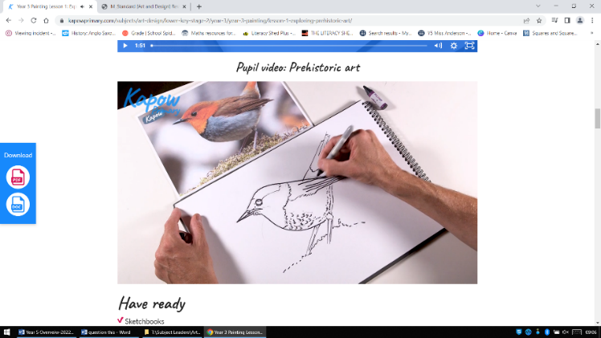  Lesson 1 |  | 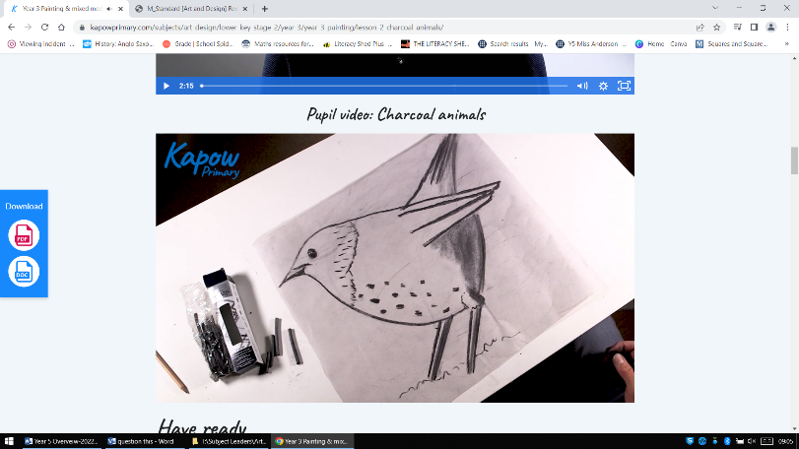  Lesson 2 | 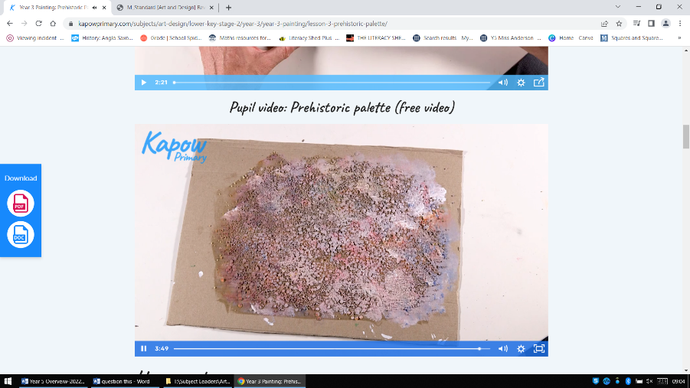  Lesson 3 |  |  | 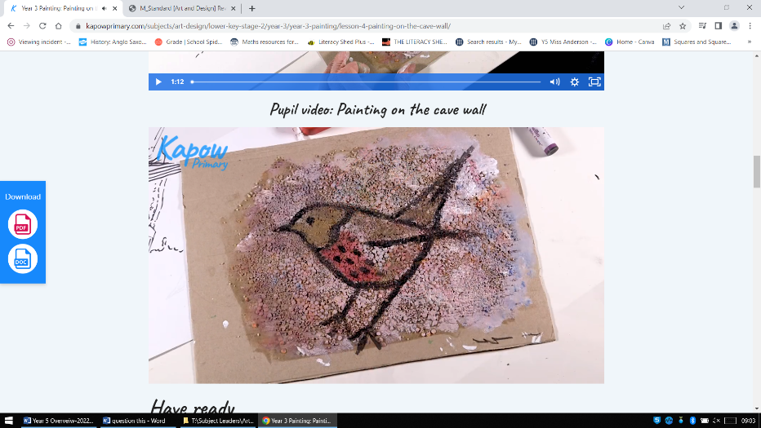  Lesson 4 | 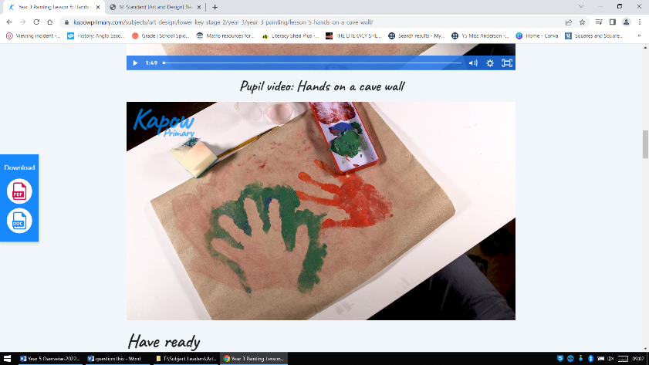  Lesson 5
Spring Term
Unit: Drawing: Growing artists (botanical art) | - To improve their mastery of art and design techniques, including drawing, painting and sculpture with a range of materials [for example, pencil, charcoal, paint, clay]  - Learn about great artists, architects and designers in history  *link with plants topic in science |  |  |  | Using botanical drawings and scientific plant studies as inspiration, pupils  explore the techniques of artists such as Georgia O’Keefe and Maud Purdy to draw natural forms, becoming aware of differences in the choice of drawing medium, scale and the way tonal shading can help create form.  - To recognise how artists use shape in drawing.  - To understand how to create tone in drawing by shading.  - To understand how texture can be created and used to make art.  - To apply observational drawing skills to create detailed studies.  - To explore composition and scale to create abstract drawings. |  |  | abstract  arrangement  blend  botanical  botanist  composition  cut  dark  even  expressive  form  frame  frottage  geometric |  | gestural  grip  light  line  magnified  organic  object  pressure  rubbing  scale  scientific  shading  shape  smooth
Key knowledge:
- To know that different drawing tools can create different types of lines.
- To know that pattern can be man-made (like a printed wallpaper) or natural (like a giraffe’s skin).
- To know that texture in an artwork can be real (what the surface actually feels like) or a surface can be made to appear textured, as in a drawing using shading to recreate a fluffy object.
- To know some basic rules for shading when drawing, e.g. shade in one direction, blend tones smoothly and with no gaps.
- To know that shading helps make drawn objects look more three dimensional.
- To know that ‘tone’ in art means ‘light and dark’.
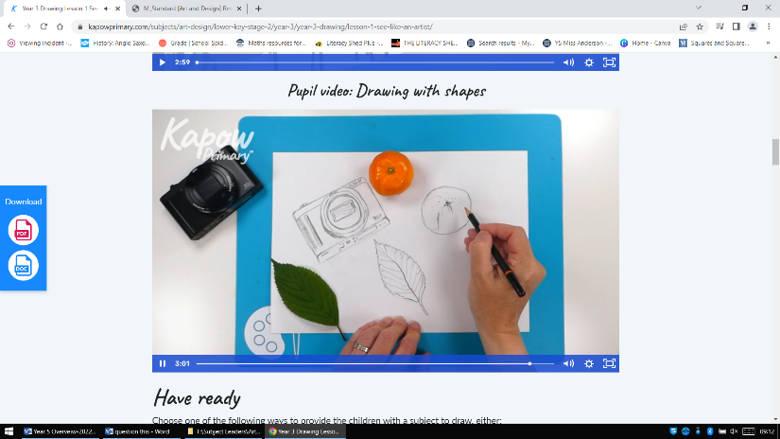  Lesson 1 |  | 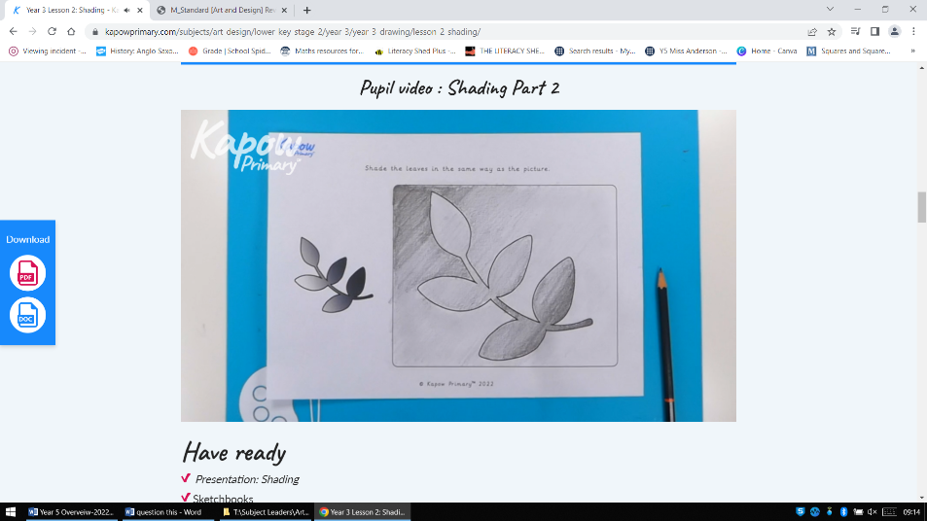  Lesson 2  Use art sketchbooks, not template | Lesson 3  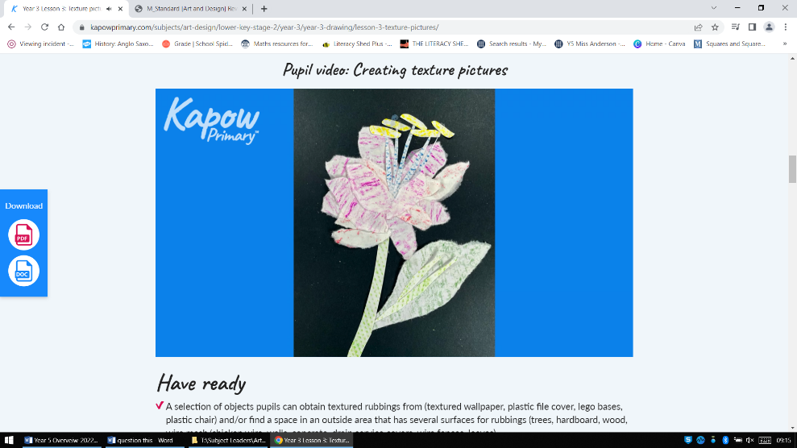 |  |  | 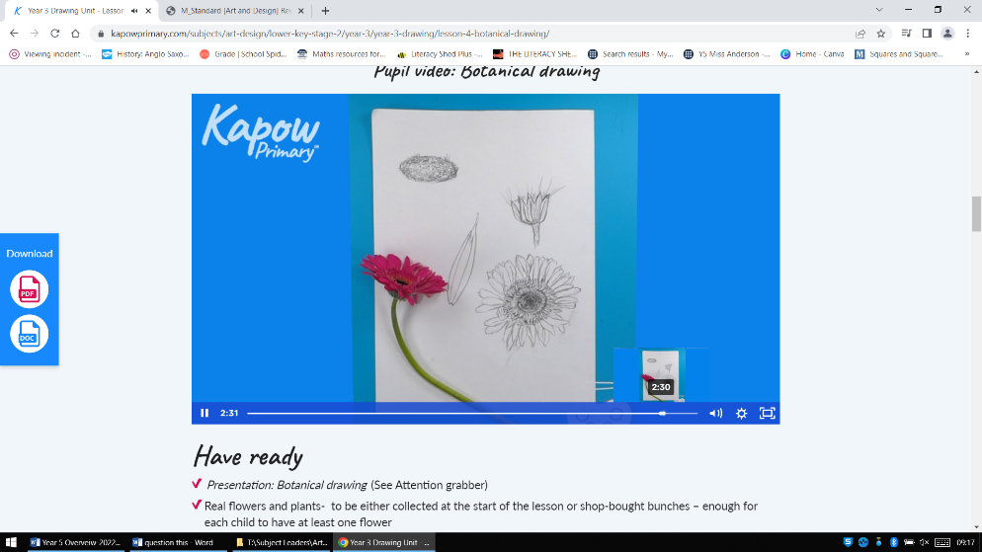  Lesson 4 | 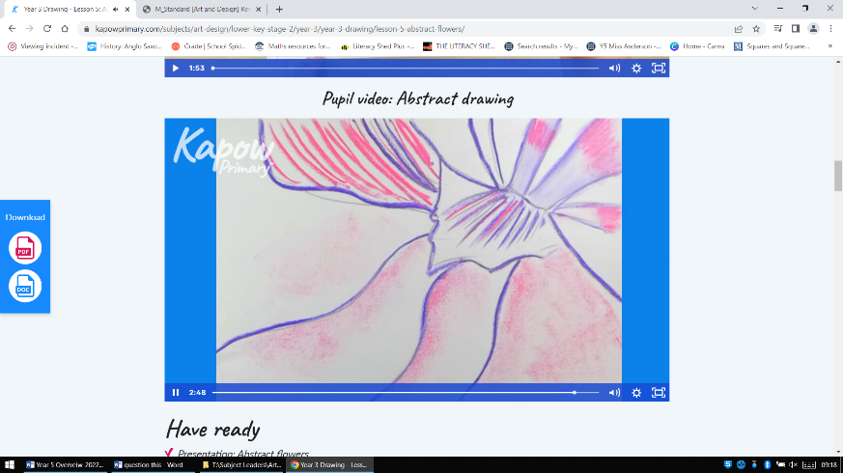  Lesson 5
Summer Term
Unit: Craft and Design: Egyptian scrolls | - To improve their mastery of art and design techniques, including drawing, painting and sculpture with a range of materials [for example, pencil, charcoal, paint, clay]  - Learn about great artists, architects and designers in history. |  |  | Learning about the way colour, scale and pattern influenced ancient Egyptian art, children explore the technique of papermaking to create a papyrus-style scroll. Ideas are extended to create a modern response by designing a ‘zine’.  - To investigate the style, pattern and characteristics of Ancient Egyptian art.  - To apply design skills inspired by the style of an ancient civilisation.  - To apply understanding of ancient techniques to construct a new material.  - To apply drawing and painting skills in the style of an ancient civilisation.  - To apply an understanding of Egyptian art to develop a contemporary response. |  |  |  | ancient  audience  civilisation  colour  composition  convey  design  Egyptian  fold  imagery  inform  layout | material  painting  papyrus  pattern  process  scale  scroll  sculpture  shape  technique  zine
Key knowledge:
To know that texture in an artwork can be real (what the surface actually feels like) or a surface can be made to appear textured, as in a drawing using shading to recreate a fluffy object.
*link to Ancient Egypt in History
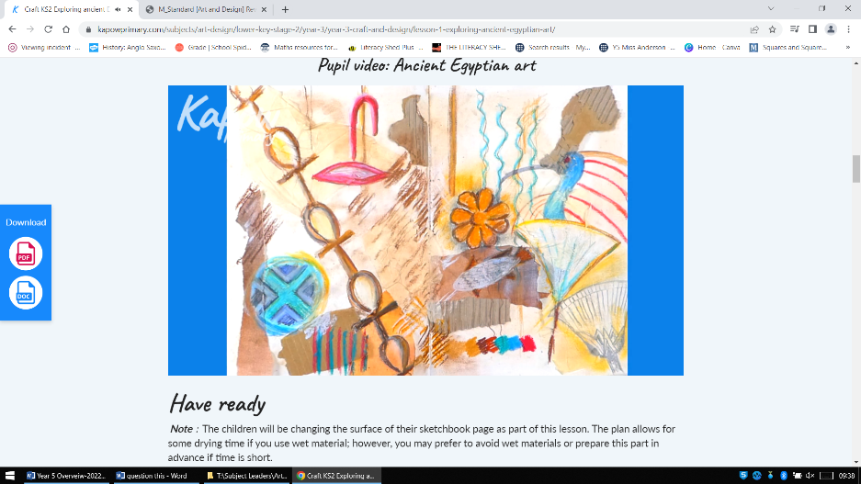  Lesson 1 |  | Lesson 2  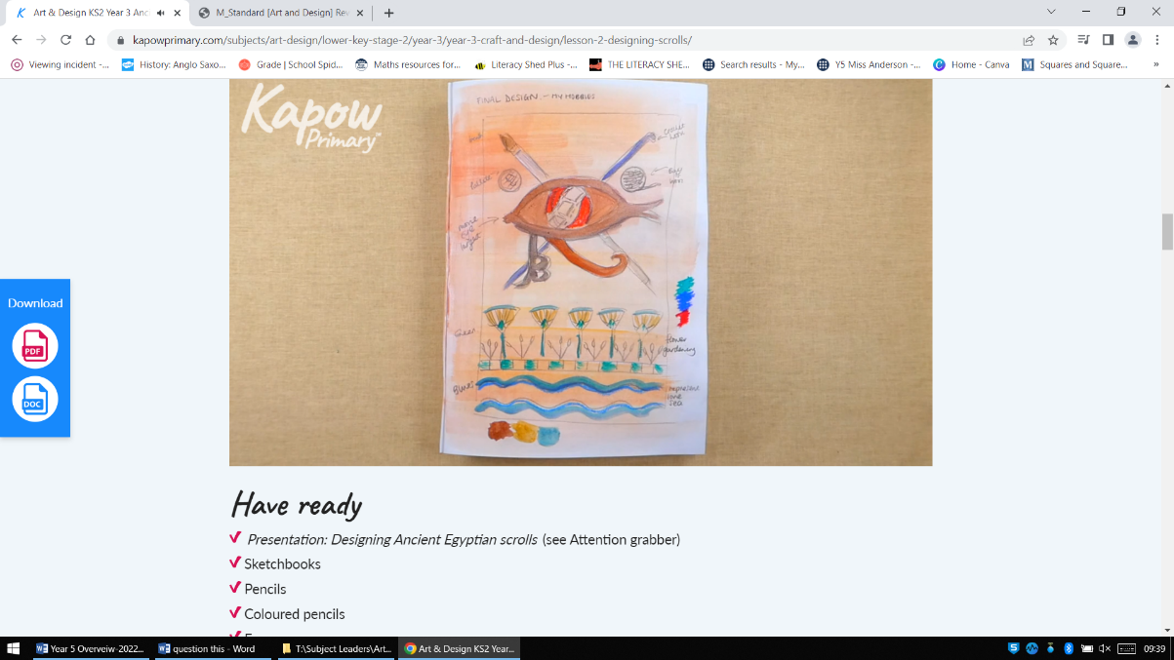 | 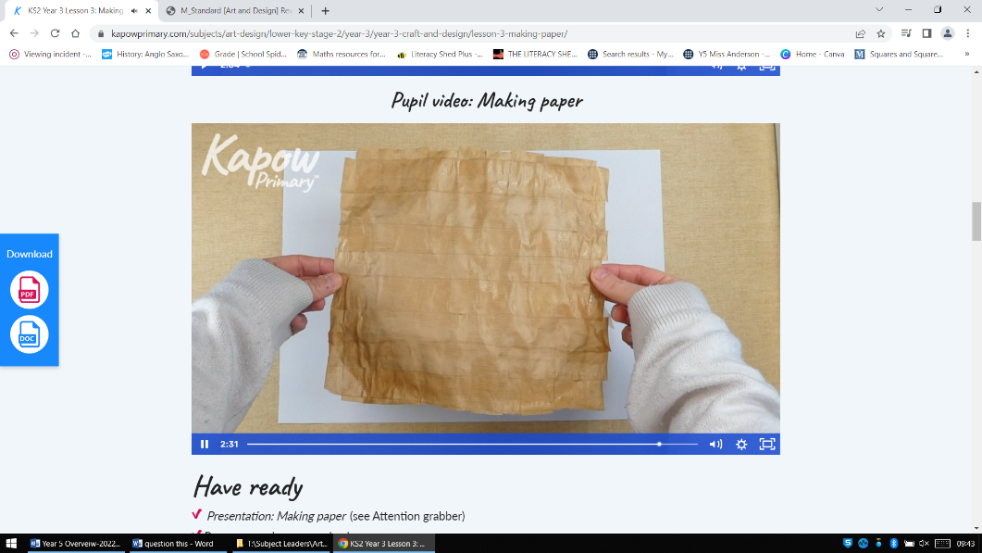  Lesson 3  Need brown paper bags and greaseproof paper |  |  | 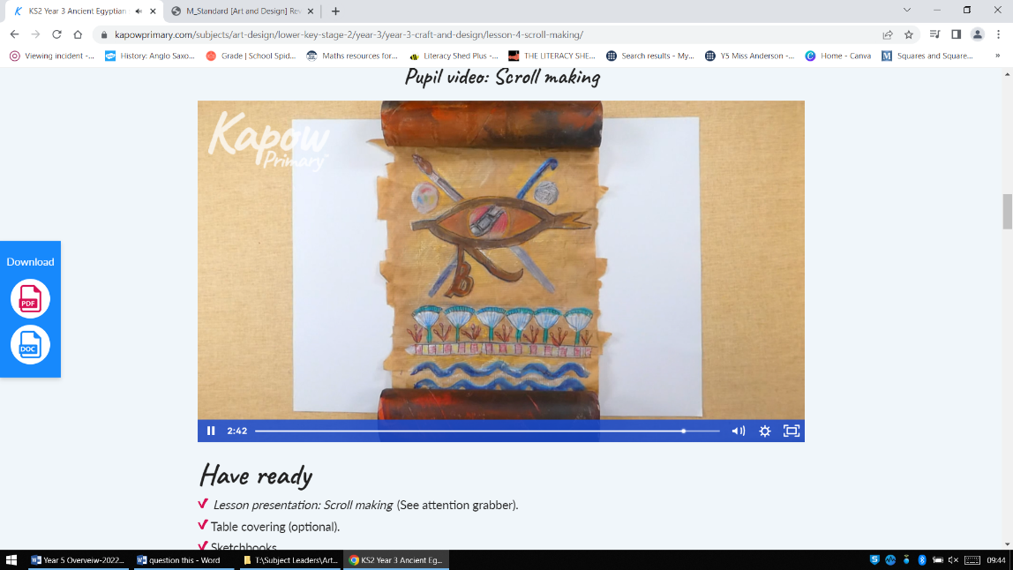  Lesson 4  Need cardboard tubes | 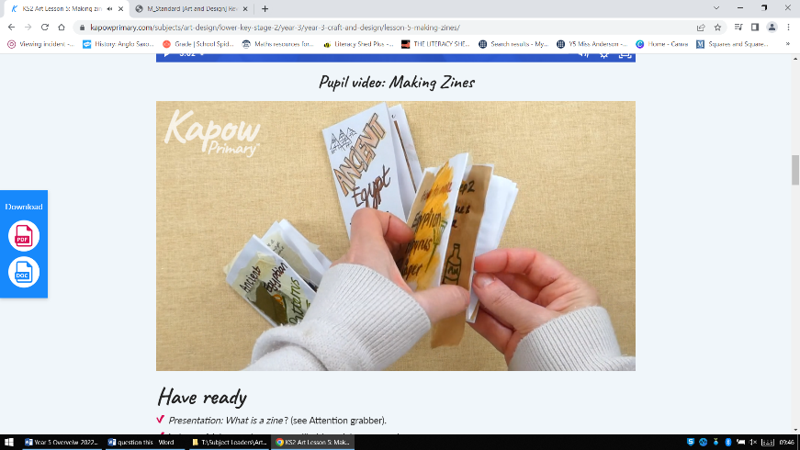  Lesson 5
Additional units are available
• Sculpture and 3D: abstract shape and space

Year 4 | National Curriculum |  |  | Progression steps |  |  |  | Vocabulary
Autumn Term
Unit: Drawing- Power Prints | - To use drawing, painting and sculpture to develop and share their ideas, experiences and imagination  - To develop a wide range of art and design techniques in using line, shape, form and space  - About the work of a range of artists, craft makers and designers, describing the differences and similarities between different practices and disciplines, and making links to their own work.  - to create sketch books to record their observations and use them to review and revisit ideas  - to improve their mastery of art and design techniques, including drawing, painting and sculpture with a range of materials [for example, pencil, charcoal, paint, clay].  - to develop their techniques, including their control and their use of materials, with creativity, experimentation and an increasing awareness of different kinds of art, craft and design. |  |  |  | Using everyday electrical items as a starting point, pupils develop an awareness of composition in drawing and combine media for effect when developing a drawing into a print.  - To draw using tone to create a 3D effect.  - To explore proportion and tone when drawing.  - To plan a composition for a mixed-media drawing.  - To use shading techniques to create pattern and contrast.  - To work collaboratively to develop drawings into prints. |  |  | abstract  block print  collaborate  collaboratively  collage  combine  composition  contrast  cross-hatching  figurative  gradient  hatching  highlight  mixed media  monoprint |  | observational drawing  parallel  pattern  precision  printmaking  proportion  shading  shadow  symmetry  three dimensional (3D)  tone  viewfinder  wax-resist
Key knowledge:
- To know how to use basic shapes to form more complex shapes and patterns.
- To know that lines can be lighter or darker, or thicker or thinner and that this can add expression or movement to a drawing.
- To know how to use texture more purposely to achieve a specific effect or to replicate a natural surface.
- To know that tone can be used to create contrast in an artwork.
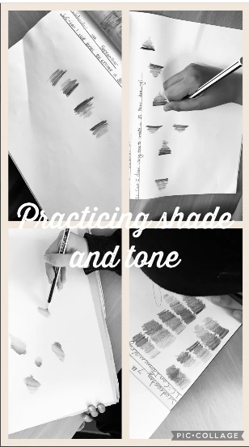  Lesson 1 |  | 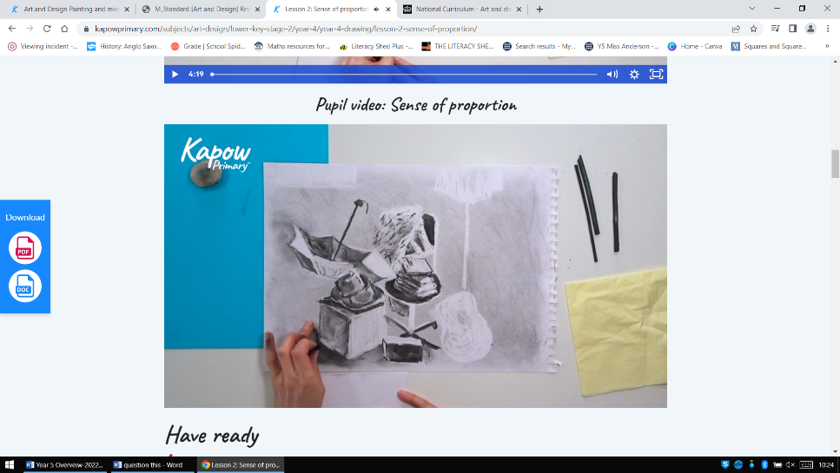  Lesson 2 | 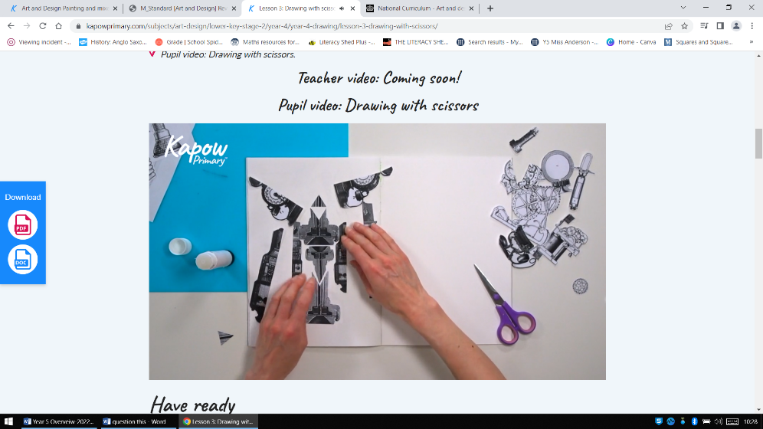  Lesson 3 |  |  | 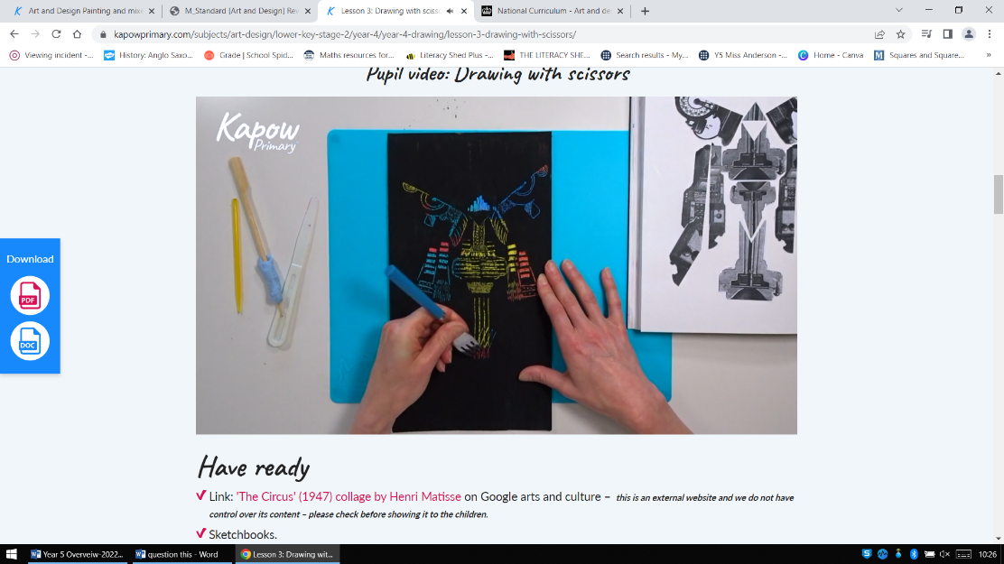  Lesson 4 | 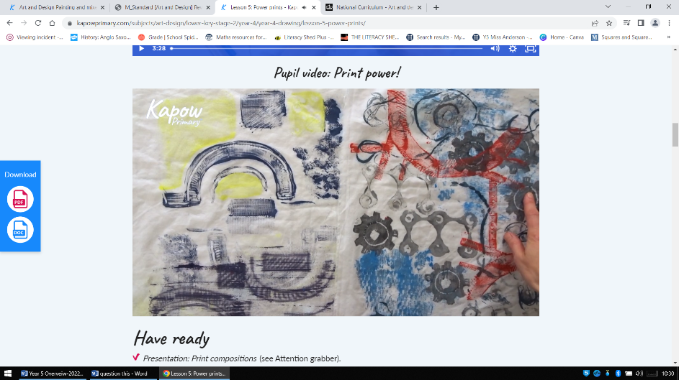  Lesson 5
Spring Term
Unit: Painting and Mixed Media- Light and Dark | - Evaluate and analyse creative works using the language of art, craft and design  - Become proficient in drawing, painting, sculpture and other art, craft and design techniques.  - to improve their mastery of art and design techniques, including drawing and painting  - know about great artists, craft makers and designers, and understand the historical and cultural development of their art forms.  *link with shape in maths |  |  | Developing colour mixing skills, using shades and tints to show form and create three dimensions when painting. Pupils learn about composition and plan their own still life to paint, applying chosen techniques.  - To investigate different ways of applying paint by mixing tints and shades of a colour  - To use tints and shades to give a three-dimensional effect when painting.  - To explore how paint can create very different effects  - To consider proportion and composition when planning a still-life painting  - To apply knowledge of colour mixing and painting techniques to create a finished piece |  |  |  | abstract  composition  contrasting  dabbing paint  detailed  figurative  formal  grid  landscape  mark-making  muted  paint wash | patterned  pointillism  portrait  shade  shadow  stippling paint  technique  texture  three dimensional (3D)  tint  vivid
Key knowledge:
- To know that adding black to a colour creates a shade.
- To know that adding white to a colour creates a tint.
- To know that using lighter and darker tints and shades of a colour can create a 3D effect.
- To know how to use texture more purposefully to achieve a specific effect or to replicate a natural surface.
- To know that using lighter and darker tints and shades of a colour can create a 3D effect. To know that tone can be used to create contrast in an artwork.
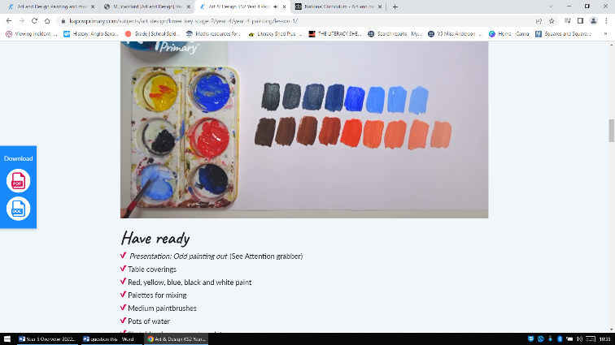  Lesson 1 |  | Lesson 2  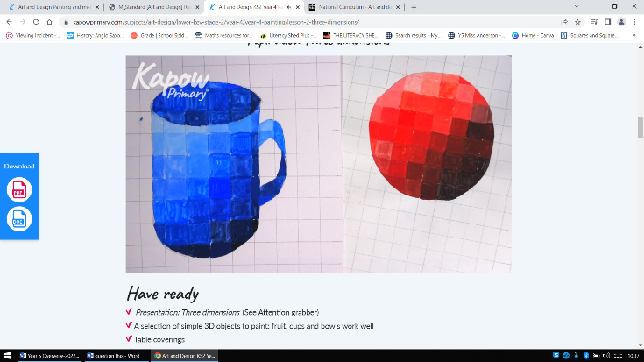  Large squared paper needed | Lesson 3  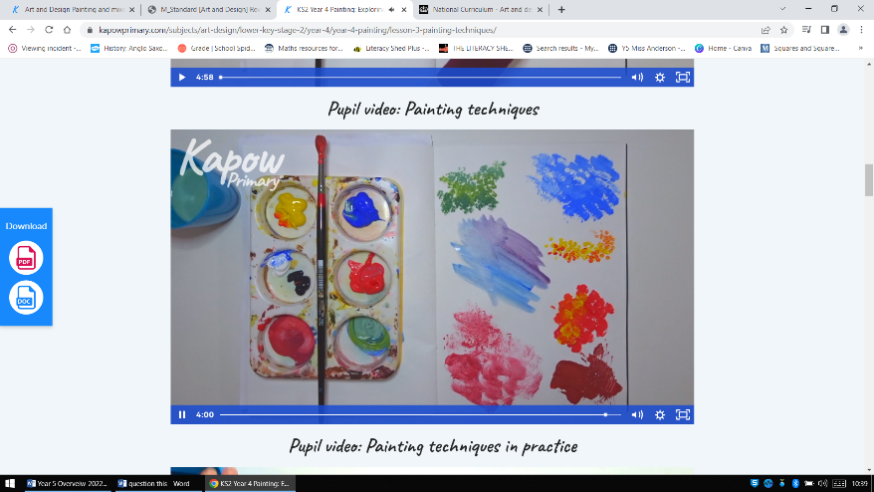 |  |  | 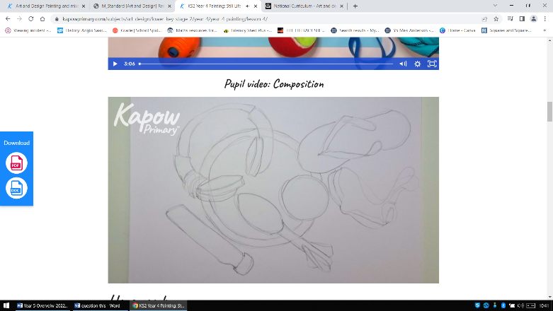  Lesson 4 | 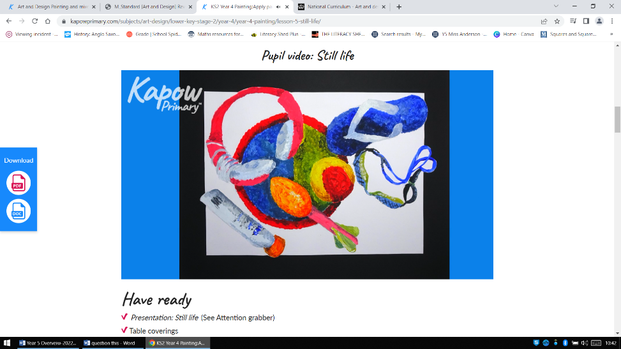  Lesson 5
Summer Term
Unit: Craft and design- fabric of nature | - to create sketch books to record their observations and use them to review and revisit ideas  - about great artists, architects and designers in history.  *Link to plants of the world: geography |  |  | Using flora and fauna of tropical rainforests as a starting point, children develop drawings through experimentation and textile-based techniques to a design a repeating pattern suitable for fabric.  - To understand starting points in a design process.  - To explore techniques to develop imagery.  - To explore using a textile technique to develop patterns.  - To learn how to create a repeating pattern.  - To understand how art is made for different purposes. |  |  |  | batik  colour palette  craft  craftsperson  design  develop  designer  imagery  industry  inspiration | mood board  organic  pattern  repeat  repeating  rainforest  symmetrical  texture  theme
Key knowledge:
- To know how to use basic shapes to form more complex shapes and patterns.
- To know that symmetry can be used to create repeating patterns.
- To know that patterns can be irregular, and change in ways you wouldn’t expect.

Additional units:
Sculpture and 3D: Mega materials

Year 5 | National Curriculum |  |  | Progression steps |  |  |  | Vocabulary
Autumn Term
Unit: Painting and mixed media- Portraits | - to create sketch books to record their observations and use them to review and revisit ideas  - to improve their mastery of Art and design techniques, including drawing, painting and sculpture with a range of materials [for example, pencil, charcoal, paint, clay] |  |  | Investigating self-portraits by a range of artists, children use photographs of themselves as a starting point for developing their own unique self-portraits in mixed-media.  - To explore how a drawing can be developed.  - To combine materials for effect.  - To identify the features of self-portraits  - To develop ideas towards an outcome by experimenting with materials and techniques.  - To apply knowledge and skills to create a mixed-media self-portrait. |  |  |  | art medium  atmosphere  background  carbon paper  collage  composition  continuous line drawing  evaluate  justify  mixed media  monoprint | multi media  paint wash  portrait  printmaking  represent  research  self-portrait  texture  transfer
Key knowledge:
- To know that artists use colour to create an atmosphere or to represent feelings in an artwork, for example by using warm or cool colours.
- To know that different marks and lines can be used to create specific effects.
- To know that artists create pattern to add expressive detail and texture to art works.
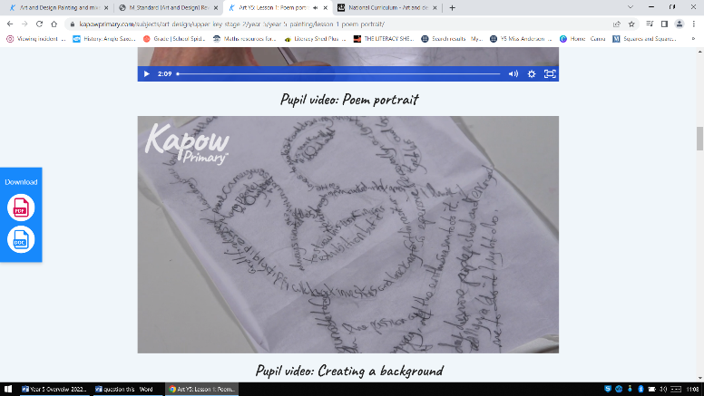  Lesson 1 |  | Lesson 2  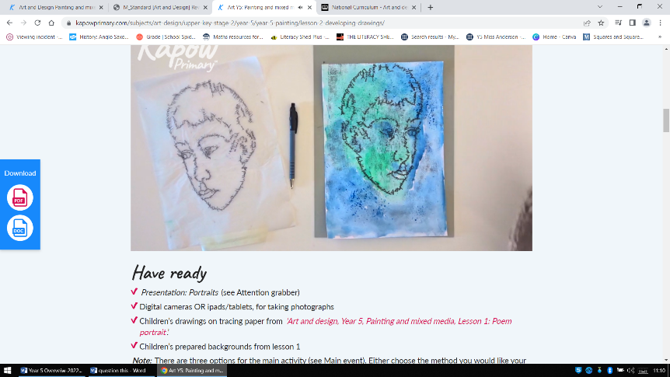 | Lesson 3  Annotate famous portraits |  | 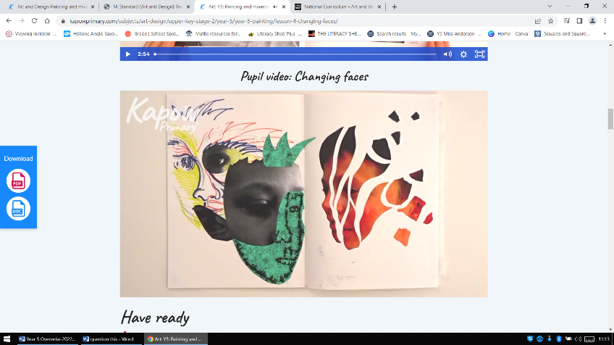  Lesson 4 |  | 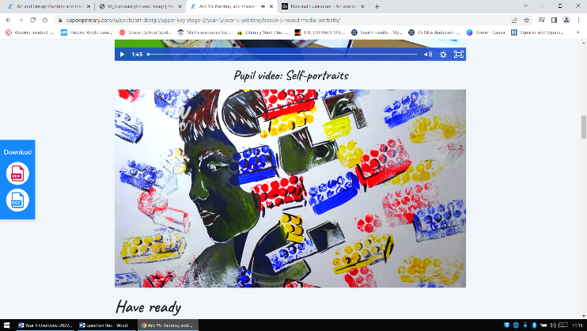  Lesson 5
Spring Term
Unit: Drawing- I need space! | - to create sketch books to record their observations and use them to review and revisit ideas  - about great artists, architects and designers in history.’  - to develop their techniques, including their control and their use of materials, with creativity, experimentation and an increasing awareness of different kinds of art, craft and design.  - to improve their mastery of art and design techniques, including drawing, painting and sculpture with a range of materials [for example, pencil, charcoal, paint, clay] |  |  | Developing ideas more independently, pupils consider the purpose of drawings as they investigate how imagery was used in the ‘Space race’ that began in the 1950s. They combine collage and printmaking to create a piece in their own style.  - To explore the purpose and effect of imagery.  - To understand and explore decision making in creative processes.  - To develop drawn ideas through printmaking.  - To test and develop ideas using sketchbooks.  - To apply an understanding of drawing processes to revisit and improve ideas. |  |  |  | cold war  collagraph  collagraphy  composition  culture  decision  develop  evaluate  futuristic  imagery  printing plate | printmaking  process  propaganda  purpose  repetition  Retrofuturism  revisit  space race  stimulus  technique
Key knowledge:
- To know that different marks and lines can be used to create specific effects.
- To know how to create texture on different materials.
- To know that prints need contrast between light and dark areas to make the image visible.
Lesson 1  Annotation |  | 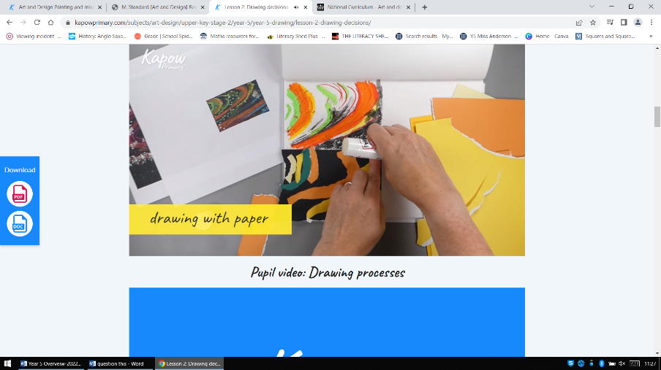  Lesson 2 | 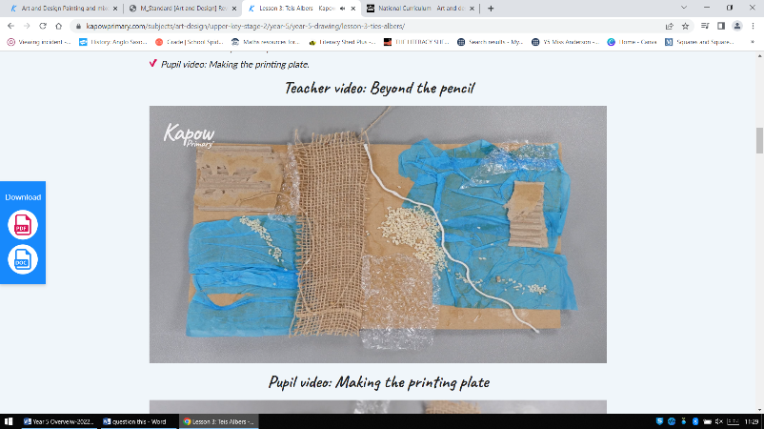  Lesson 3 |  | 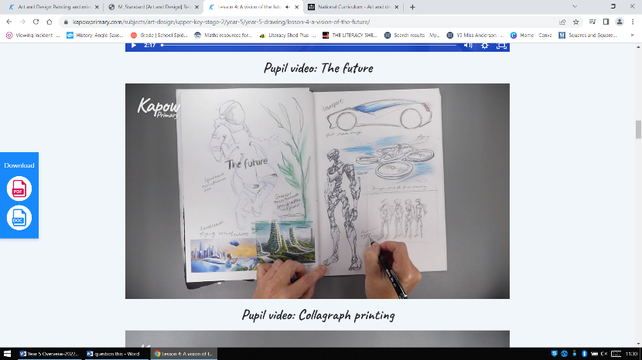  Lesson 4 |  | 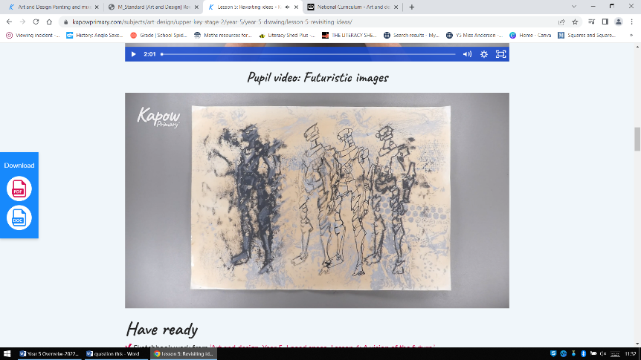  Lesson 5
Summer Term
Unit: Craft and Design: Architecture | - To develop their techniques, including their control and their use of materials, with creativity, experimentation and an increasing awareness of different kind of art, craft and design.  - To create sketchbooks to record their observations and use them to review and revise ideas  - To improve their mastery of art and design techniques, including drawing, painting and sculpture with a range of materials [for example, pencil, charcoal, paint, clay]  - Learn about great artists, architects and designers in history’ |  |  | Investigating the built environment through drawing and printmaking, learning about the work of architect Zaha Hadid and creating their own building designs, creatively presenting research on artist Hundertwasser and exploring ideas behind the symbolism of monument design.  - To apply observational drawing skills to interpret forms accurately.  - To apply composition skills to develop a drawing into print.  - To apply an understanding of architecture to design a building.  - To extend design ideas through research and sketchbook use.  - To explore and evaluate the intention of a design. |  | Abstract annotate architect architectural architecture birds eye view built environment commemorate composition crop design design brief design intention elevation evaluate external form futuristic individuality interpret legacy literal monoprint monument observational drawing organic perspective pressure
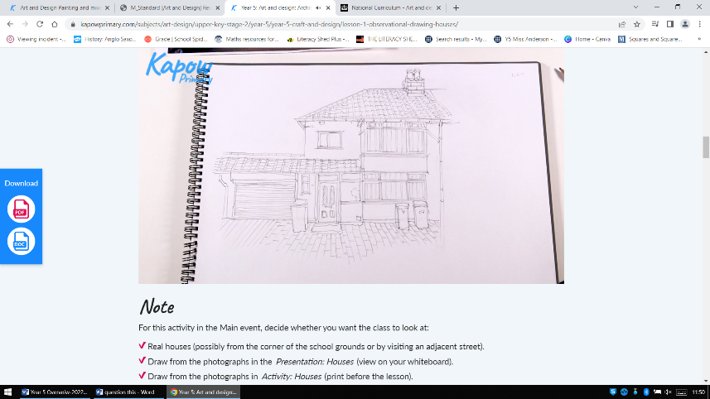  Lesson 1 |  | 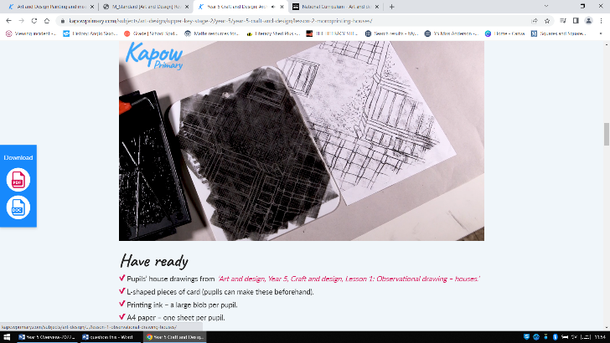  Lesson 2 | 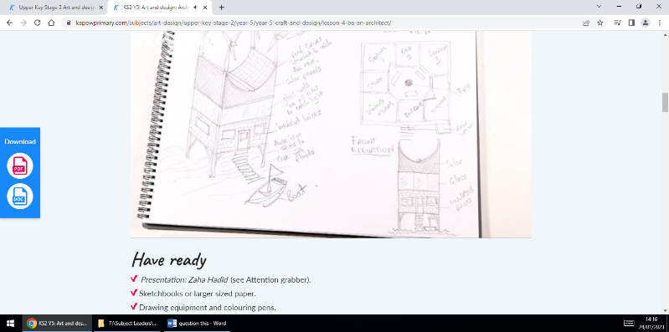  Lesson 3 |  | 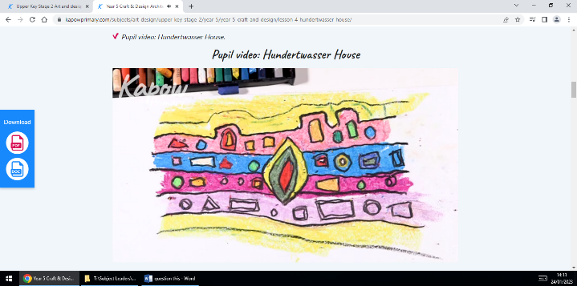  Lesson 4 |  | 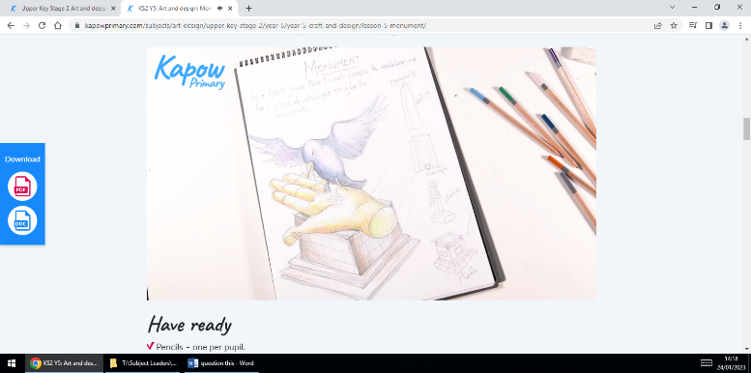  Lesson 5
Unit | Additional units:  Sculpture and 3D: Interactive installation

Year 6 | National Curriculum |  |  |  | Progression steps |  |  |  |  |  | Vocabulary
Autumn Term
Unit: Craft and design- Photo opportunity | Art and design  ‘Pupils should be taught to develop their techniques, including their control and their use of materials, with creativity, experimentation and an increasing awareness of different kinds of art, craft and design.  Pupils should be taught:  - to create sketch books to record their observations and use them to review and revisit ideas  - to improve their mastery of art and design techniques, including drawing, painting and sculpture with a range of materials [for example, pencil, charcoal, paint, clay]  - about great artists, architects and designers in history.’ |  |  |  | Developing photography skills and techniques to design a range of creative photographic outcomes.  - To apply an understanding of composition to create an effective photomontage advertising poster.  - To apply understanding of abstract art through photography.  - To demonstrate an understanding of design choices made for effect using digital photography techniques.  - To apply an understanding of photography to design and recreate a famous painting.  - To demonstrate observation and proportion to create art in a photorealistic style. |  |  |  |  |  | album  arrangement  cityscape  composition  Dada  digital  editing  emulate  focus  frame  grid  image  layout  macro  monochromatic |  |  |  | monochrome  photography  photomontage  photorealism  photorealistic  portrait  pose  prop  proportion  recreate  replacement  saturation  software
Lesson 1  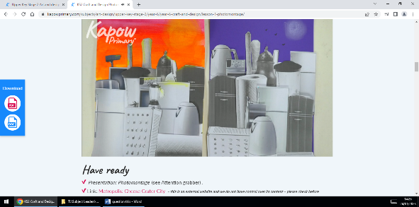 |  |  | Lesson 2  Taking and editing photographs |  |  | 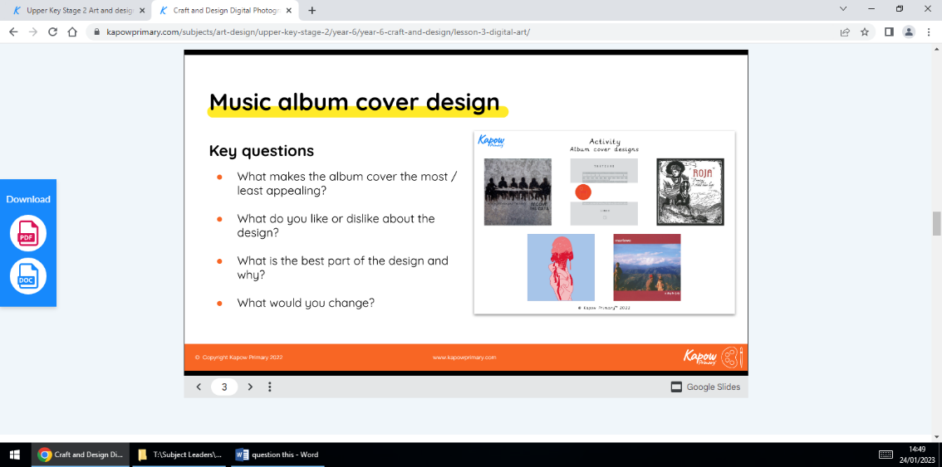  Lesson 3 |  |  | Lesson 4  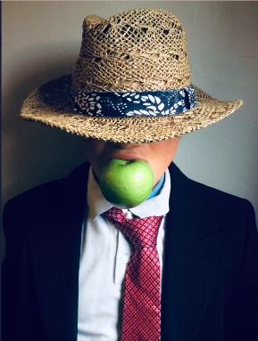 |  |  | 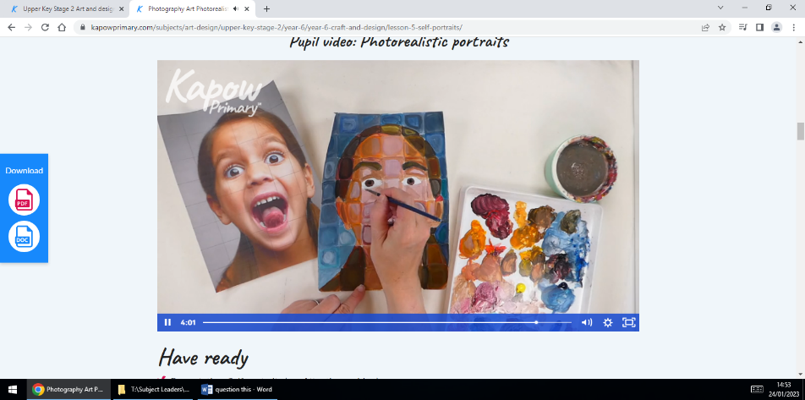  Lesson 5
Spring Term
Unit: Drawing- Making my voice heard | Art and design  ‘Pupils should be taught  - to develop their techniques, including their control and their use of materials, with creativity, experimentation and an increasing awareness of different kinds of art, craft and design.  - to create sketch books to record their observations and use them to review and revisit ideas  - to improve their mastery of art and design techniques, including drawing, painting and sculpture with a range of materials [for example, pencil, charcoal, paint, clay]  - about great artists, architects and designers in history.’ |  |  |  | From the Ancient Maya to modern-day street art, children look at how artists convey a message. Exploring imagery, symbols, expressive mark making, and ‘chiaroscuro’ children consider audience and impact to create powerful drawings to make their voices heard.  - To explore expressive drawing techniques.  - To consider how symbolism in art can convey meaning.  - To apply understanding of the drawing technique chiaroscuro.  - To evaluate the context and intention of street art.  - To apply an understanding of impact and effect to create a powerful image. |  |  |  |  |  | aesthetic  audience  character traits  chiaroscuro  commissioned  composition  expressive  graffiti  guerilla  imagery  impact  interpretation |  |  | mark making  Maya  Mayan  mural  representative  street art  symbol  symbolic  technique  tone  tonal
Lesson 1  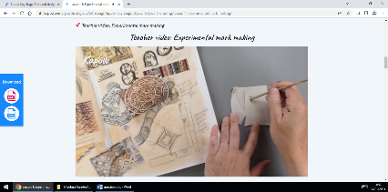 |  |  | Lesson 2  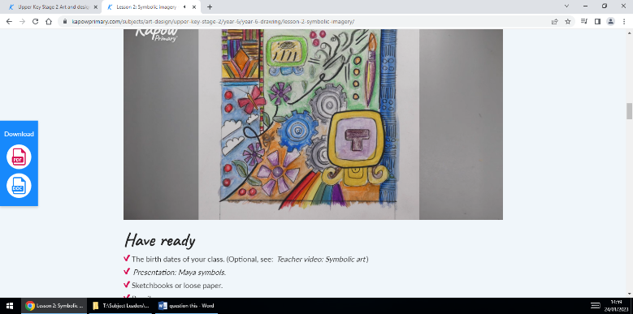 |  |  | Lesson 3  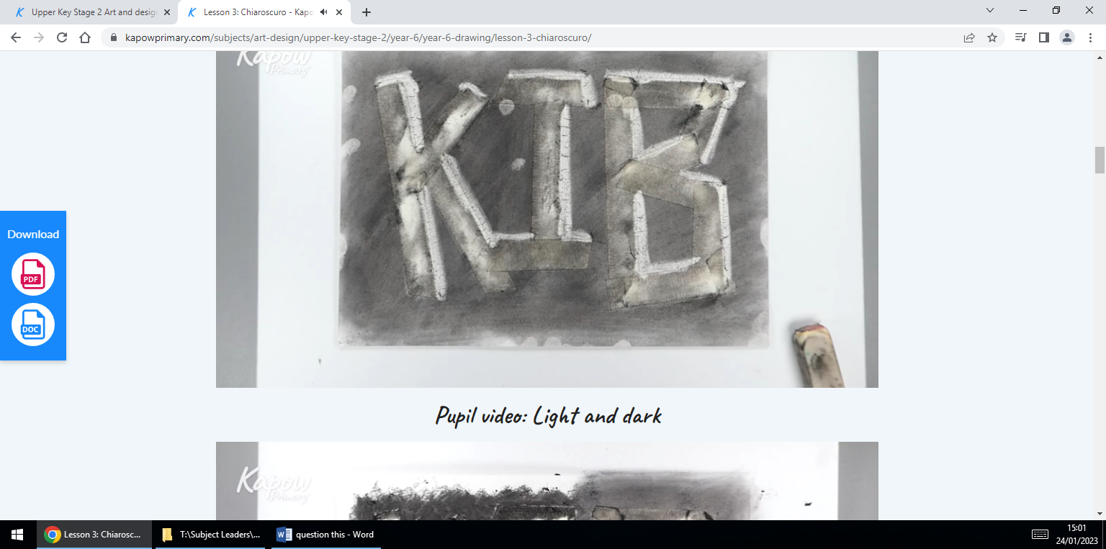 |  |  | Lesson 4  Evaluation |  |  | Lesson 5  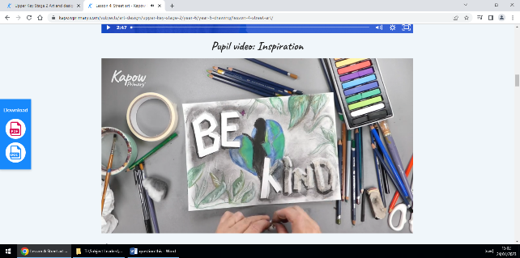
Summer Term
Unit: Painting and mixed media: Artist study | Learn about great artists, architects and designers in history.’ |  |  |  | Exploring a selection of paintings through art appreciation activities. Collecting ideas in sketchbooks and planning for a final piece after researching the life, techniques and artistic intentions of an artist that interests them.  - To understand how to analyse a famous painting.  - To understand how to find meaning in painting.  - To apply drama techniques to explore the meaning of a painting  - To apply interpretation skills to analyse and respond to an abstract painting  - To understand how art can tell stories or portray messages  - To develop starting points for creative outcomes  - To demonstrate an understanding of painting techniques to make personal choices |  |  |  |  |  | abstract  analyse  artist  compose  compositions  convey  evaluation  inference  interpret  justify |  |  | meaning  medium  mixed media  narrative  respond  tableau  technique  thought-provoking  translate
Lesson 1 option 1:  David Hockney  Lesson 1 option 2:  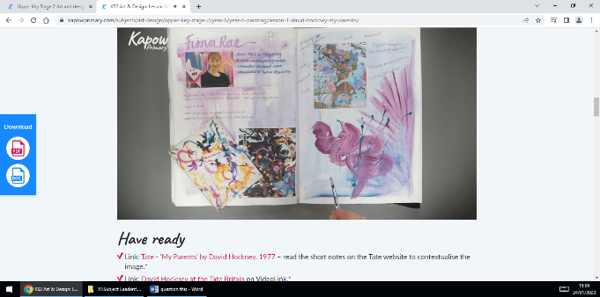  Richard Brakenburg |  | Lesson 2  Paula Rego- the dance |  | Lesson 3  John Singer- Sergant: The front line |  |  | Lesson 4  Fiona Rae option 1  Frank Bowling option 2 | Lesson 5  Lubaina Himid |  | Lesson 6  Research and planning |  |  | Lesson 7  Making art
Additional unit (post SATs)
- Sculpture and 3D: Making memories

